Free DJ Lessons: How to use a DJ Controller

If you are wanting to learn how to use a DJ controller you have come to the right place.

Be sure to note that this article is a follow up to the How to use a Mixer article. Read that one first, as it will discuss the features of a mixer in detail, then come back here for more information on how to use the channel controls.

What all of the Shiny Buttons do (in plain English):
You probably have seen a really nice mixer with over 100 different buttons and features. To simplify things, let’s start small and break down the very basics of your mixer.
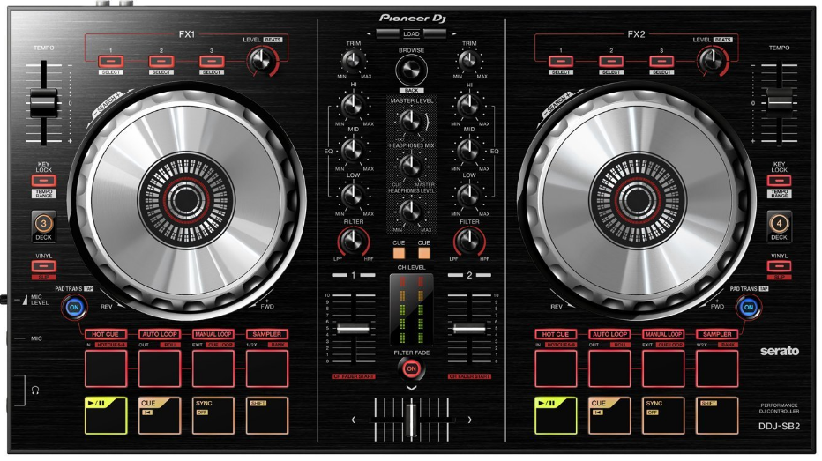
10
5
9
8
7
61
4
3
2
1
1. On every controller you will find ports to connect to your PA system. These ones are RCA outputs, and can be used with any white/red audio cable.
You might also find outputs in different sizes. With most controllers, you should be able to connect to your PA system using cords that look like this:

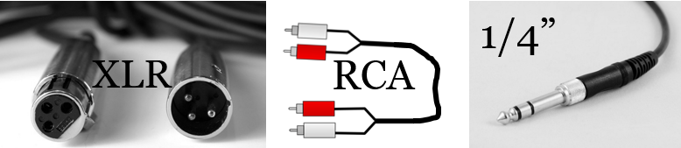

2. This part of the controller is for controlling the FX. Usually controllers carry a section like this to help with the controller’s performance with DJ software.
In certain circumstances, you may also find this sort of feature on mixers. In either case, its use is pretty straight forward when you start using it with the software.

3. You will find this control on most controllers, it is used to control the tempo of the song you are listening to. To make the track play faster, slide it towards the + sign, and if you want to slow things down you slide to the – sign.
Many DJs might slow down or speed up the tempo 4-5 BPMs gradually throughout a song to help transition to the next song. This trick allows you to be able to transition to songs that are 8-10 BPMs in your current song’s range and still sound good.
Typically, if you want to instantly match the BPM of another song, most controllers also include a “SYNC” button which can do this much more quickly than the tempo fader.
4. The platter for a typical DJ controller has two features. You can either temporarily adjust the tempo to match another song you have playing, or use it to produce a scratching sound similar to vinyl (see #7).
5. You might not find this on every controller, but this button can be used to adjust how much or little you can adjust the tempo using the tempo fader. Either if you want a
6. As you get better as a DJ, you might find yourself too comfortable with two channels, and wanting more space to add in your own personal touch. Most DJ software comes with the capability to add in four decks, and buttons like this allow you to switch to channel three or four in the software.
7. As discussed in #4, platters on most DJ controllers have two features, to scratch or smoothly adjust the tempo to blend in with a near-failed transition, for example.
8. You might not find a button like this on every controller, but if you press this it allows the drum pads (see #9) to stop the song smoothly ranging left to right from quickly to slowly. This is especially useful if you want to quickly cut a song for a transition, or stopping the music altogether.
9. There are a lot of different features here, and they are typically on any DJ controller you can buy. To make things simple let’s break things down
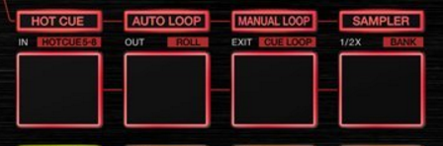
Hot Cue:
If you press this button it will allow you to use each of the pads below to quickly jump to different “cues” or certain parts of a song.
Auto Loop:
Pressing this button will enable auto loop. This is a pretty nice feature, and is useful for making quick loops to help with mixing or transitioning.
Manual Loop:
This button allows you to create your own loops. To use it simply press the “Manual Loop” button and then use the pads below to mark where your loop starts, ends, and then to play and adjust it.
Sampler:
Pressing this button will allow you to use the pads below to play and use your own short sound FX (like your DJ name). For the best results, make these buttons stop playing when you take your finger of the pad, and try scratching while you are playing with your samples.
10. With the exception of the “SHIFT” button, you will see these same buttons on any DJ controller. Let’s break them down one-by-one.
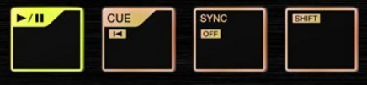
Play/Pause:
Use this button (on the far left) to play or pause the track.
Cue:
If you press this button while the music is not playing, it will mark a cue in the track. When you are centered on the cue, you can then use the “CUE” button again to play from the cue until you release your finger.
If you press this button while music is playing it will stop at the cue that you make, so be careful not to press this button on the channel your current song is playing on.
Sync:
If you press this button it will sync the BPM of the opposite channel to the BPM of the current channel.
Shift:
For any button you can see a second feature for (IE: the “CUE” button), the “SHIFT” button can give access to when held down.

Transitioning Tips:

Never slowly transition between two songs unless they are close together in BPM. When transitioning slowly, cut the bass of the song you are switching from until you have the crossfader on the other side.
- Quick transitions are great to use if the difference in BPM is high. A good rule of thumb is 8-10 being the very maximum you should bend your tempo for to do a slow transition.
- Make sure you set a nice cue point before you transition over to the next song. You need to make sure you start each song on the first beat of the first measure or it will never transition properly.
- Although you can probably not worry about this for a little while as a beginner, there are many circumstances where the key of the two songs don’t match, and will sound bad if you mix them together. As you build your skills, you will develop your ears to quickly spot out songs that don’t mix together.

Mixing Tips:

Keep the songs that you want to play on channels one and two, if you want to add in some scratching or loops, put those files on channels three or four in the software.
- Before you start to use intermediate scratching techniques like chirping, try to get good at simple tricks, like editing out a curse word without missing a beat.
- Throwing in sound FX is something that should be done sparingly, and only when it will boost the sound.
- Boost your “HI” EQs gradually when you are building up a drop in a song. The crowd will always love it, as long as you put it back down when the bass drops.

Remember:
Learning how to use a DJ controller is not an easy thing to do. As long as you keep practicing, you will soon be able to mix your tracks together like a professional.

